

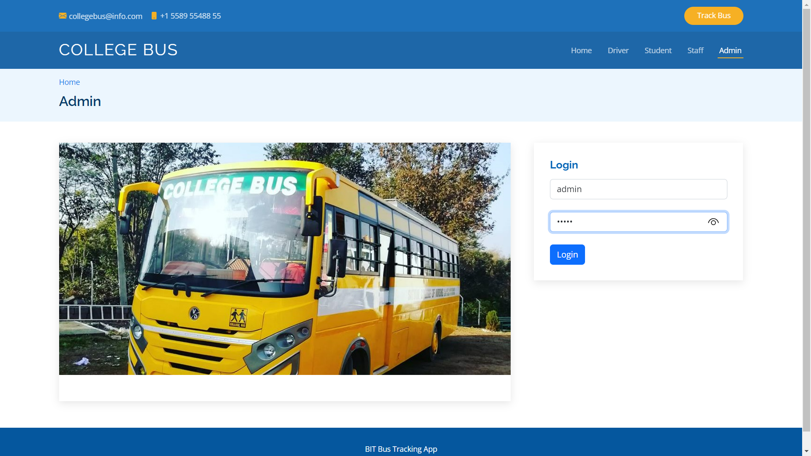

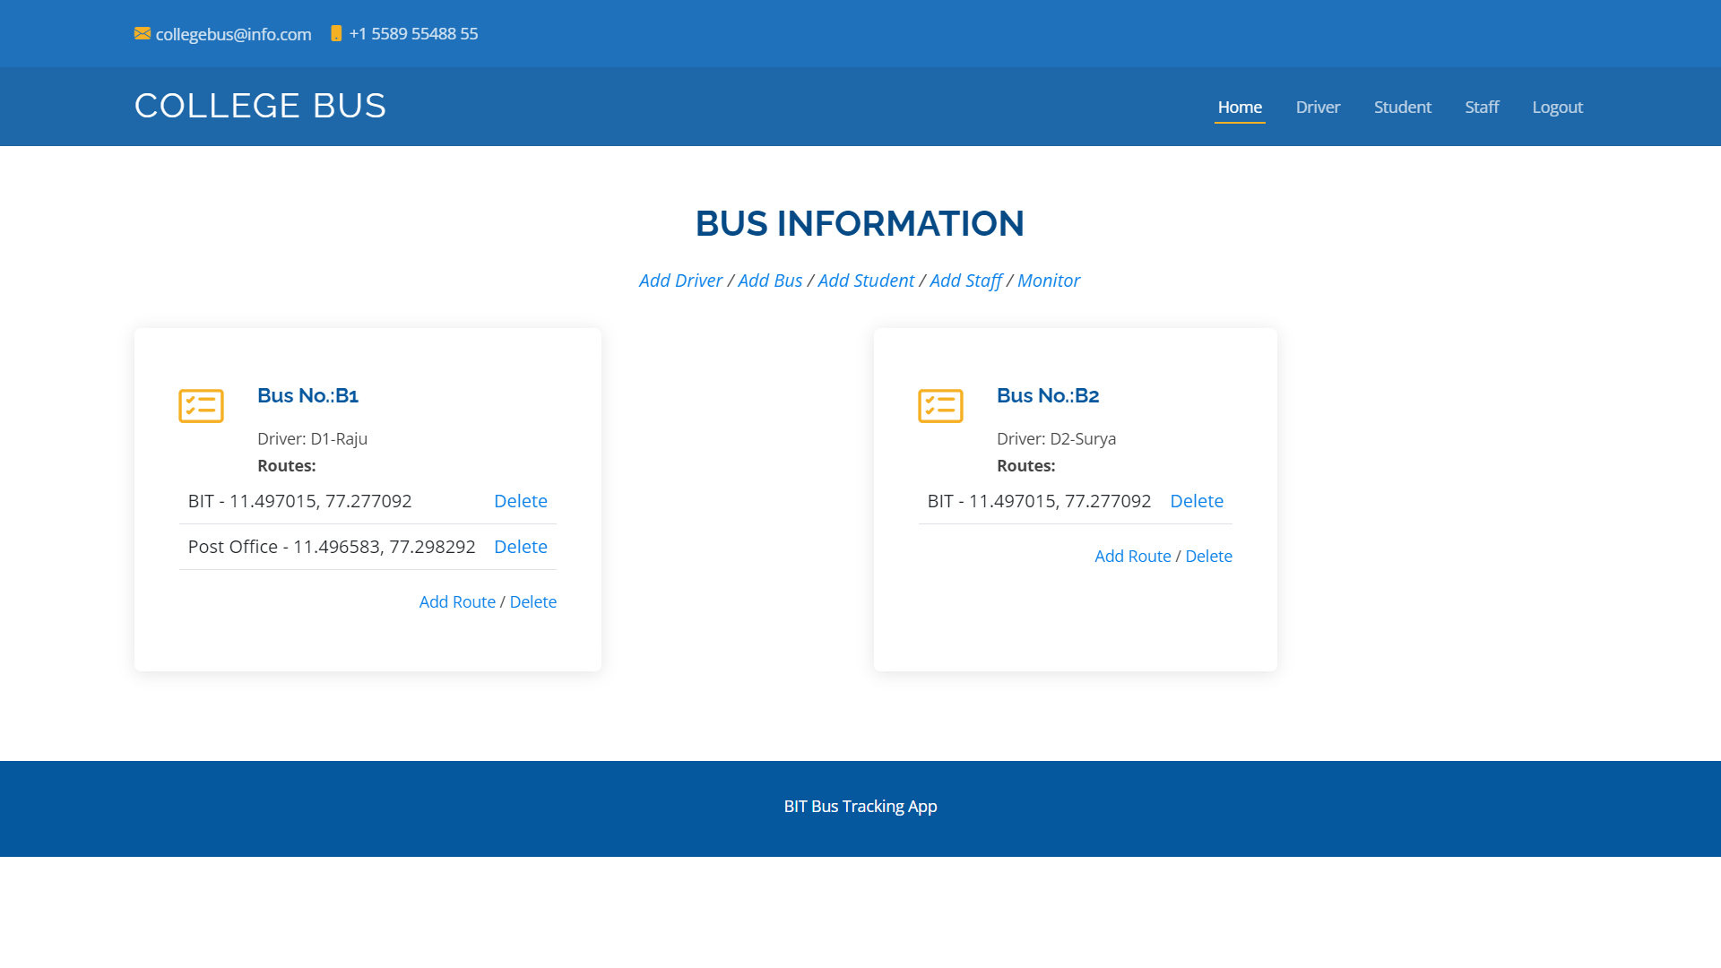

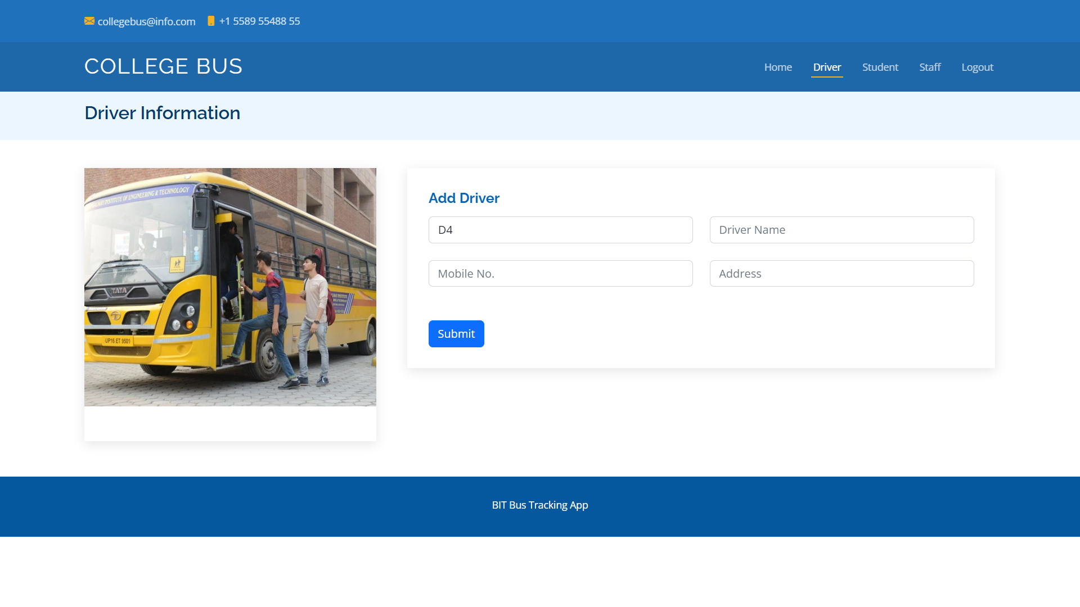

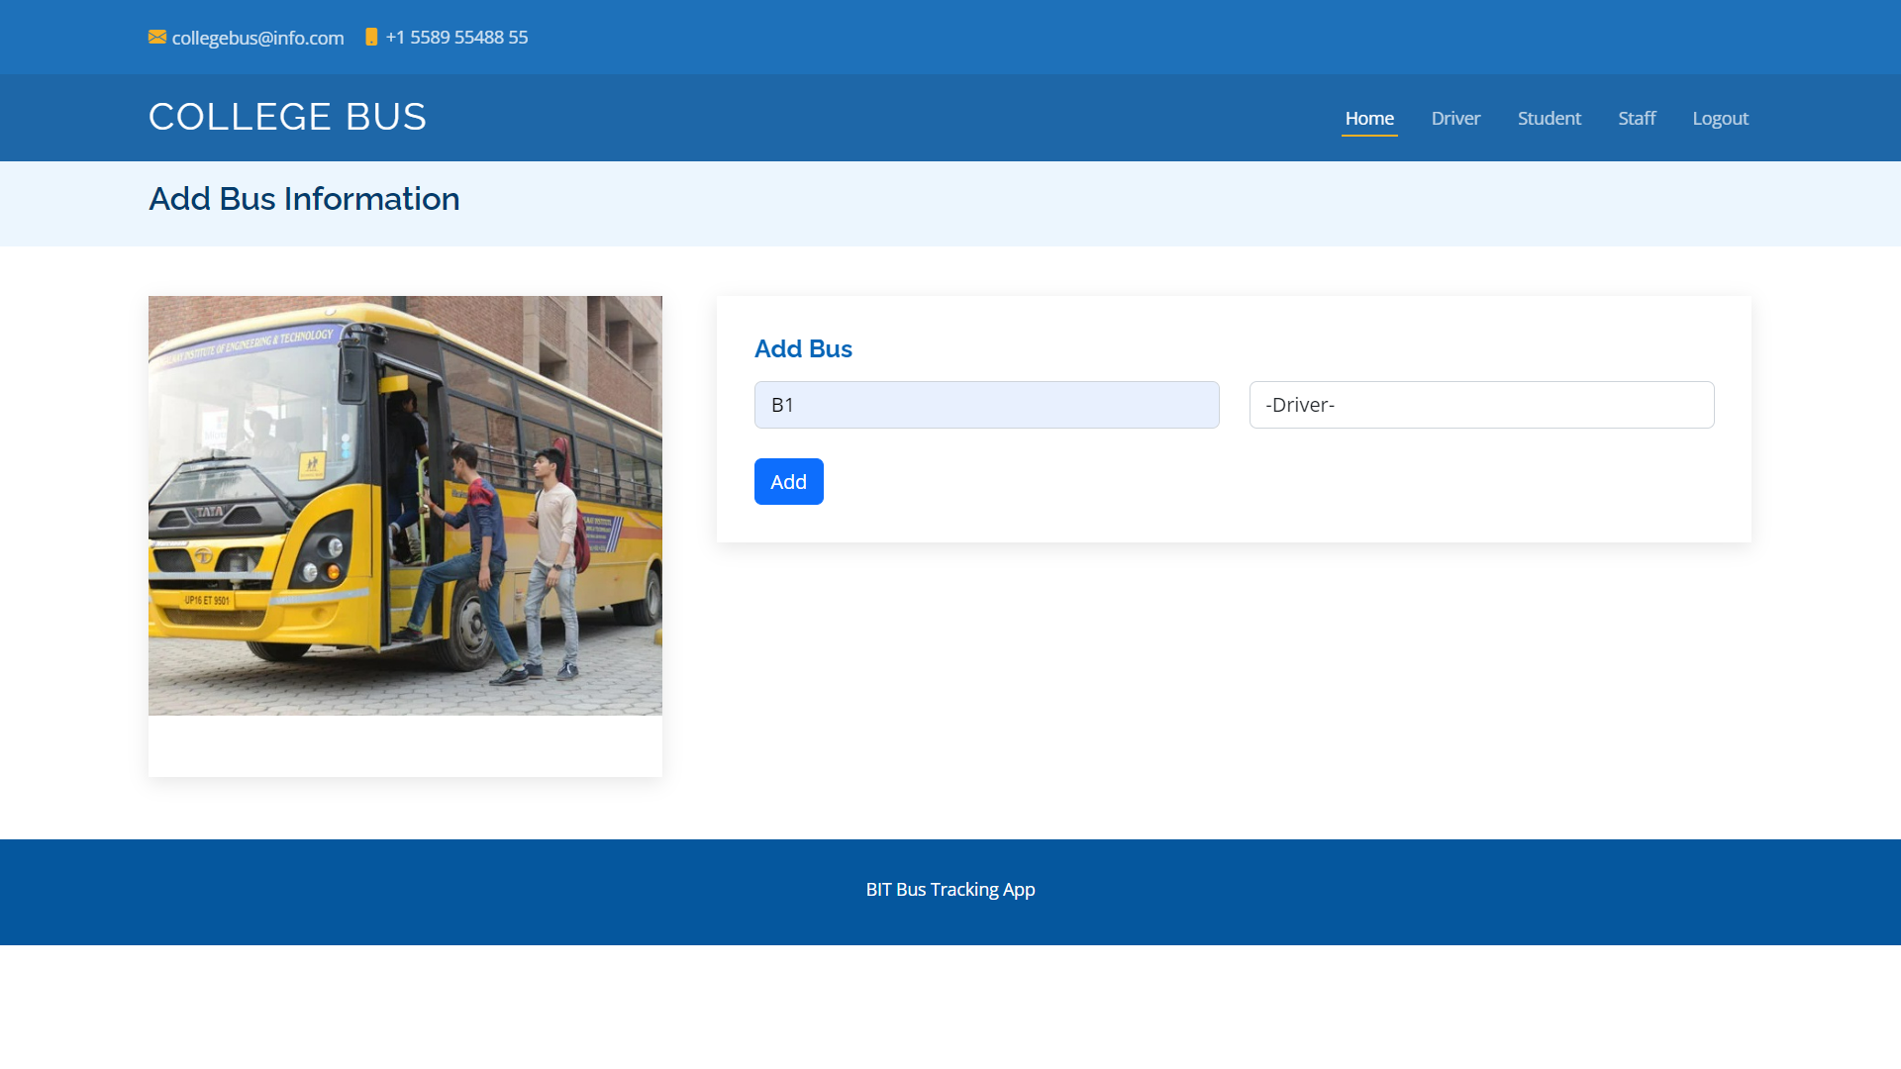

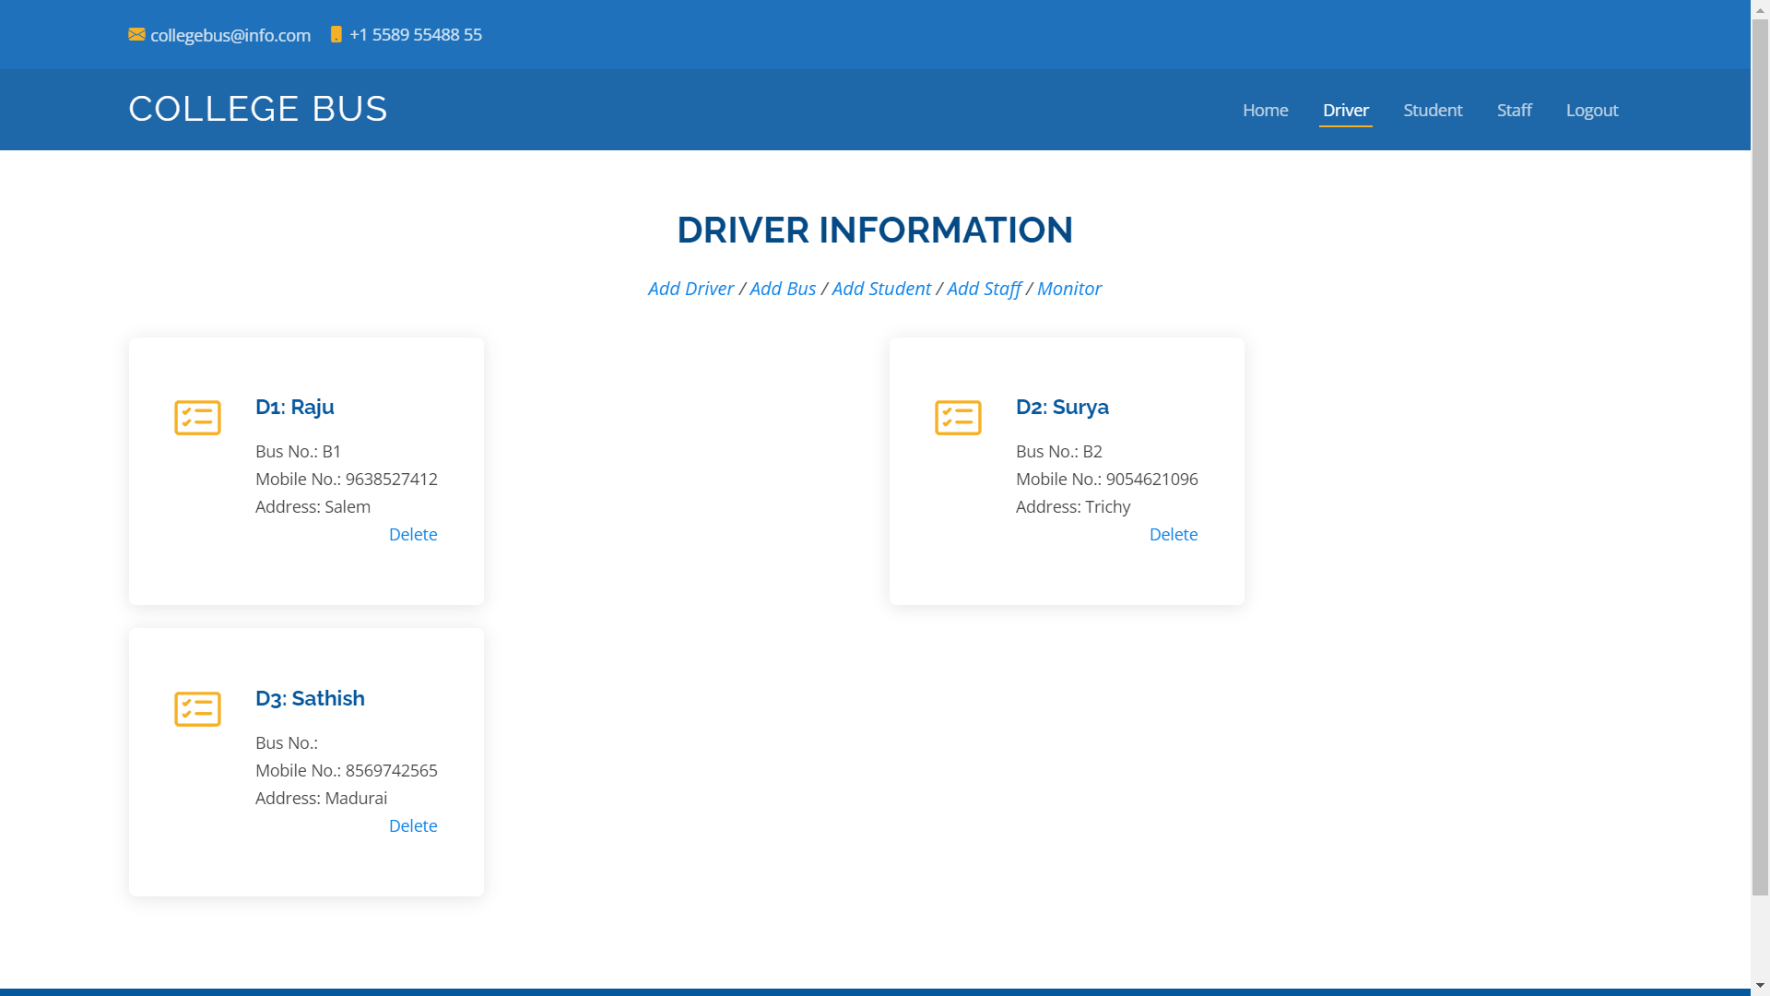

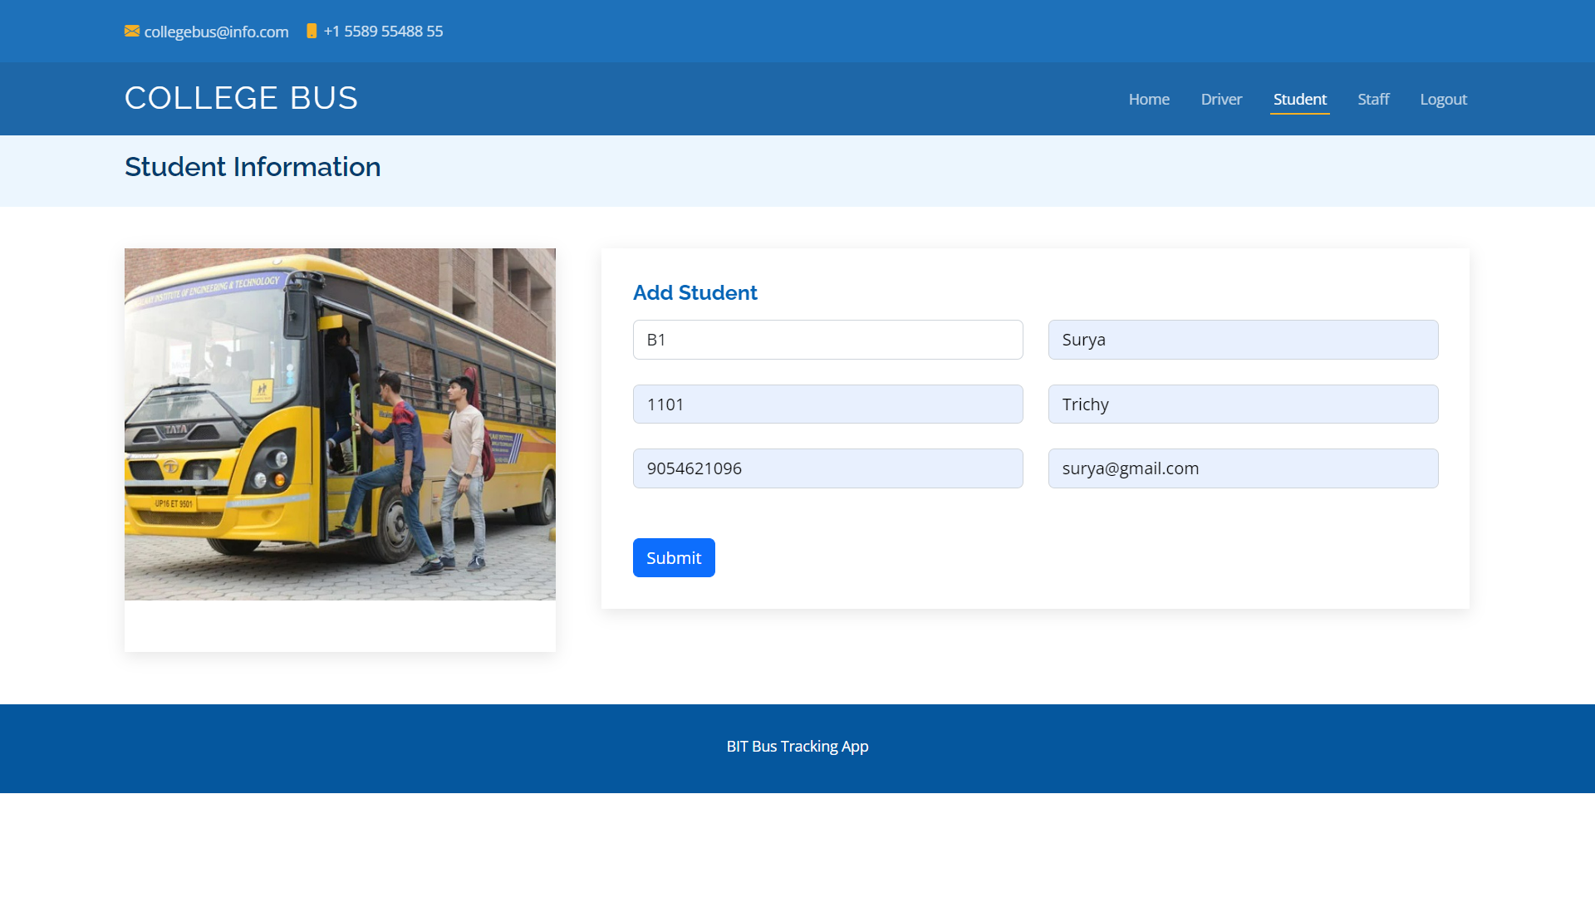

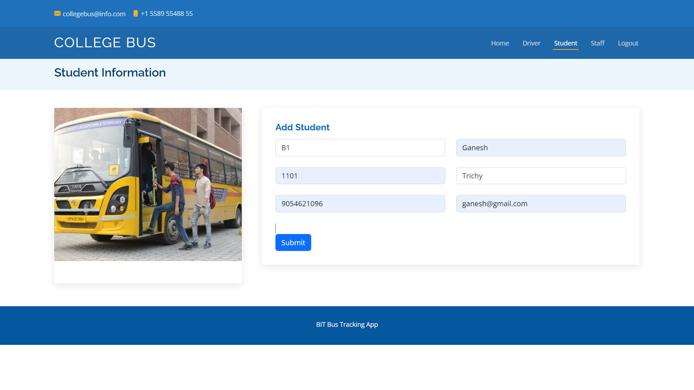

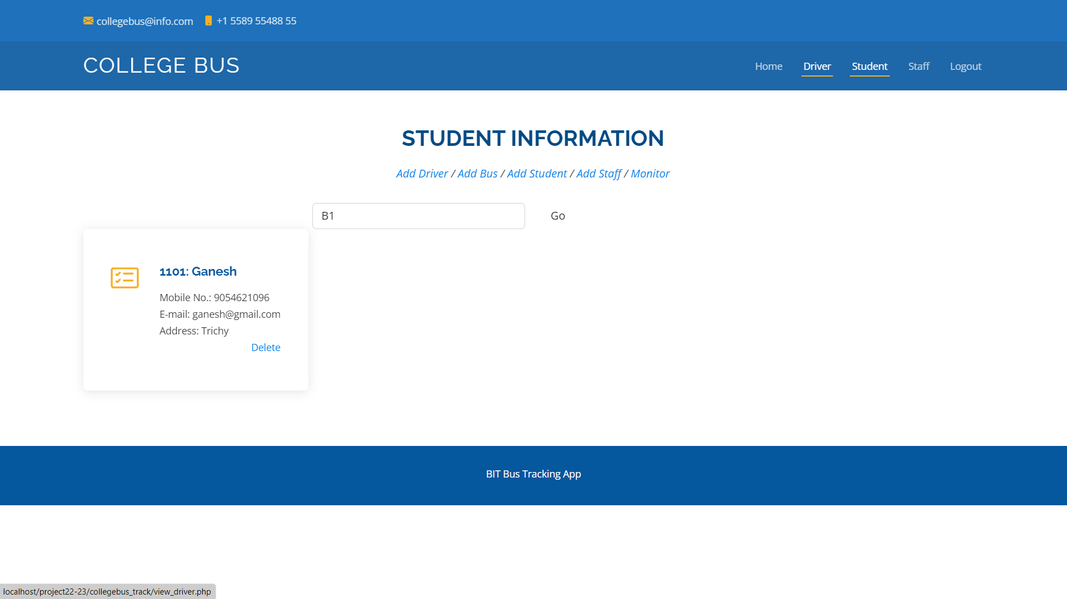

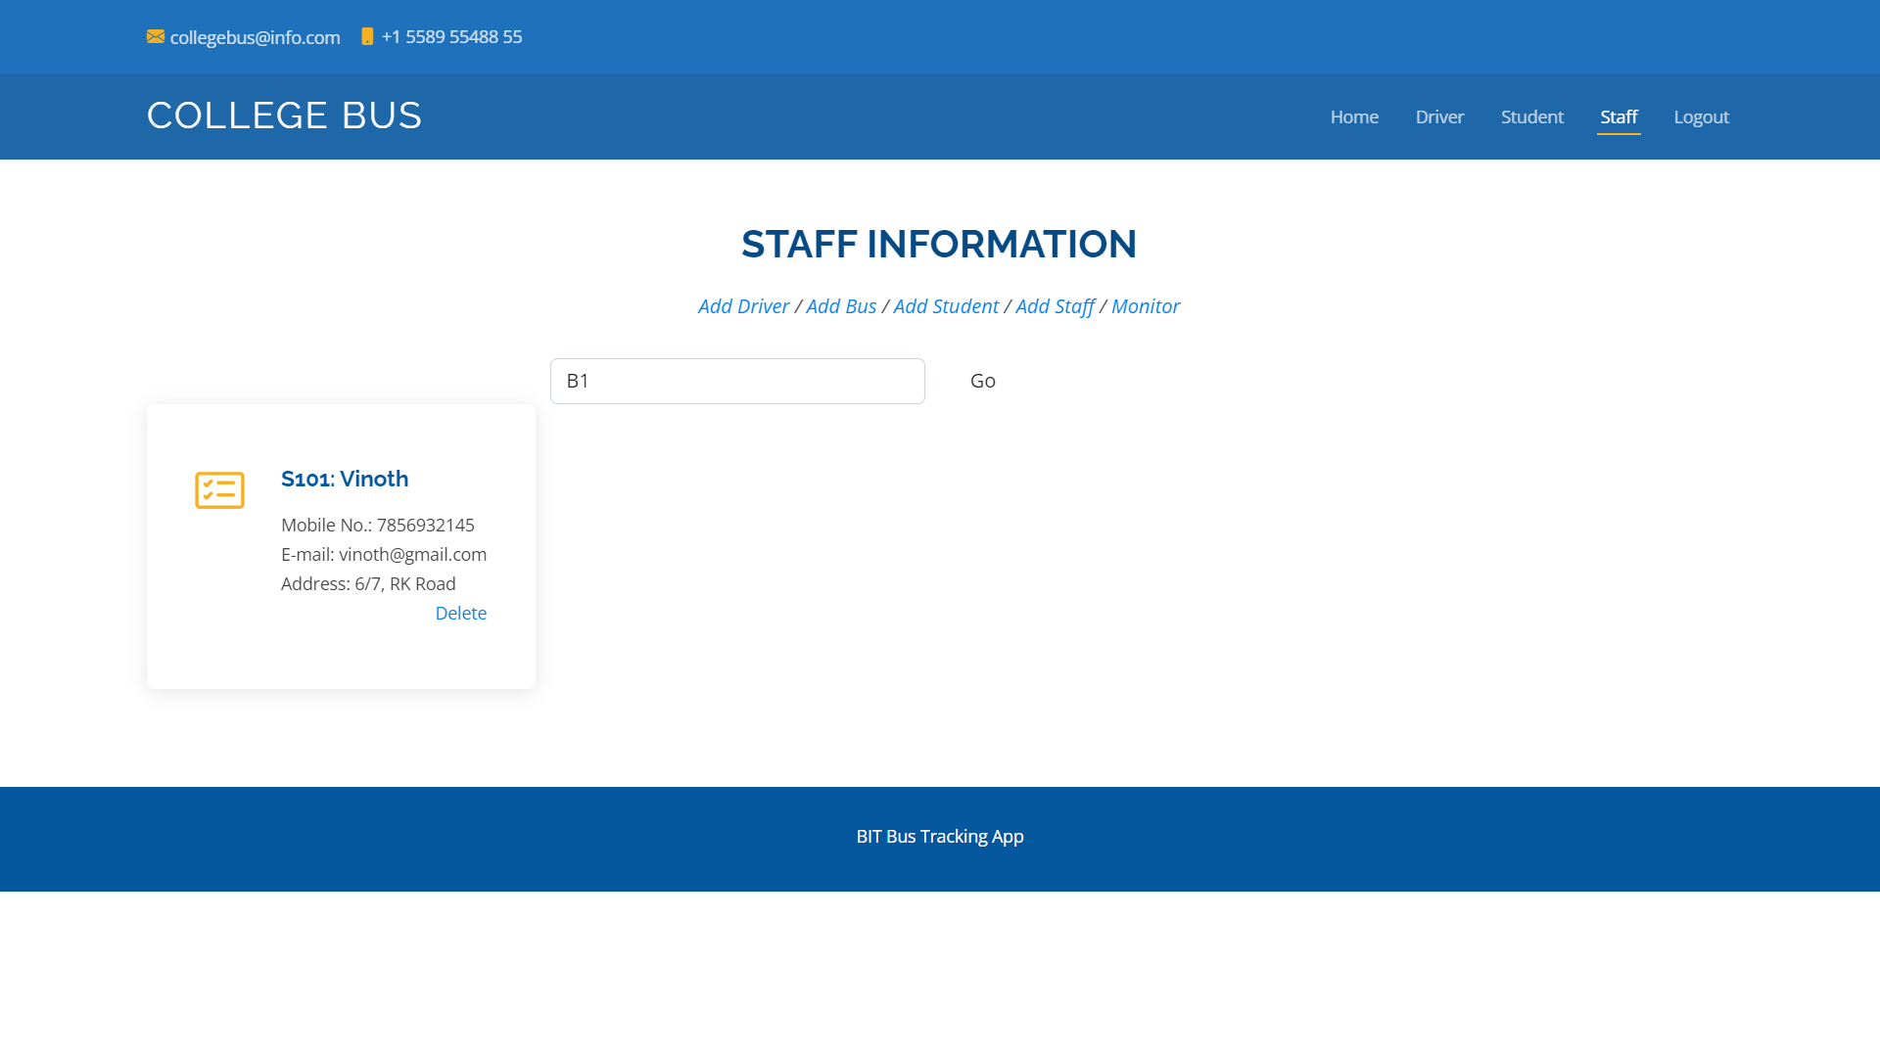

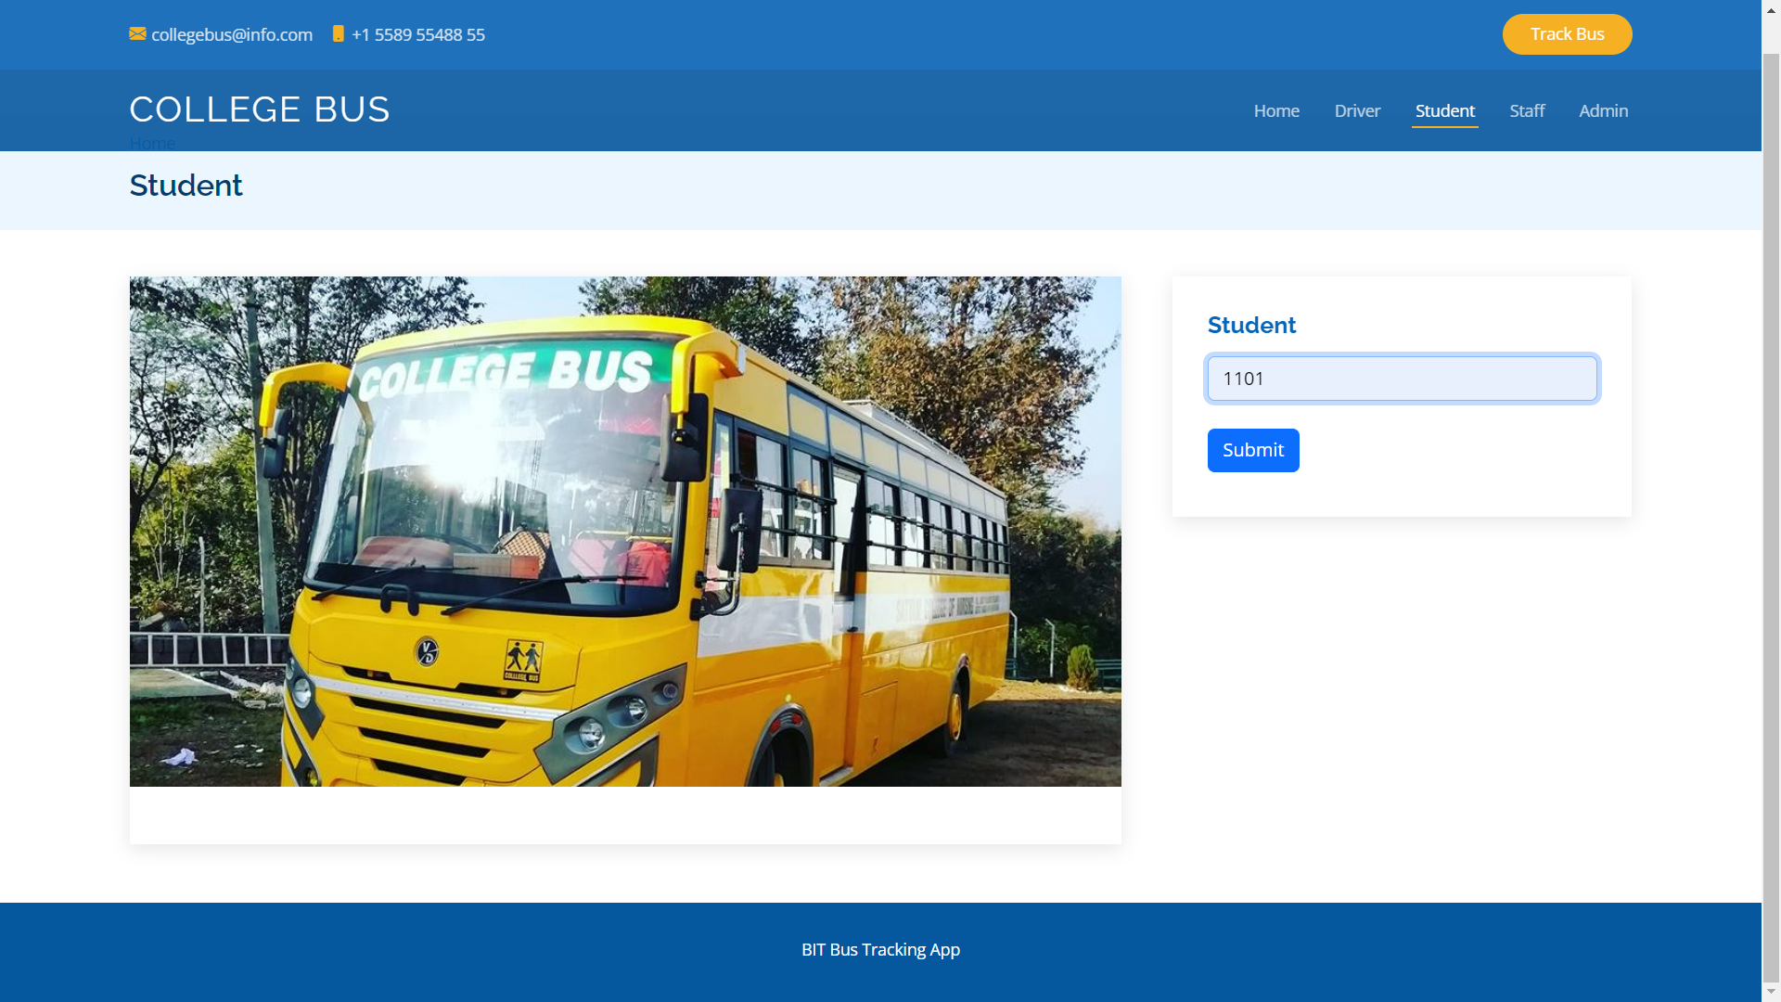

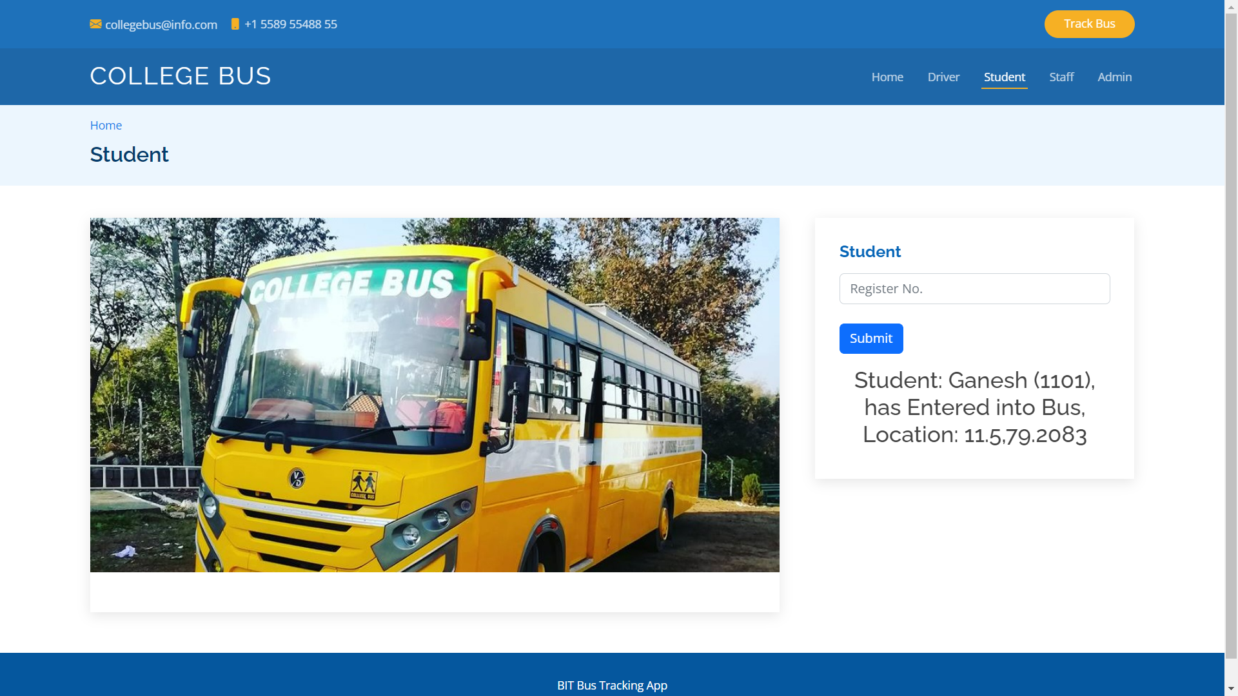

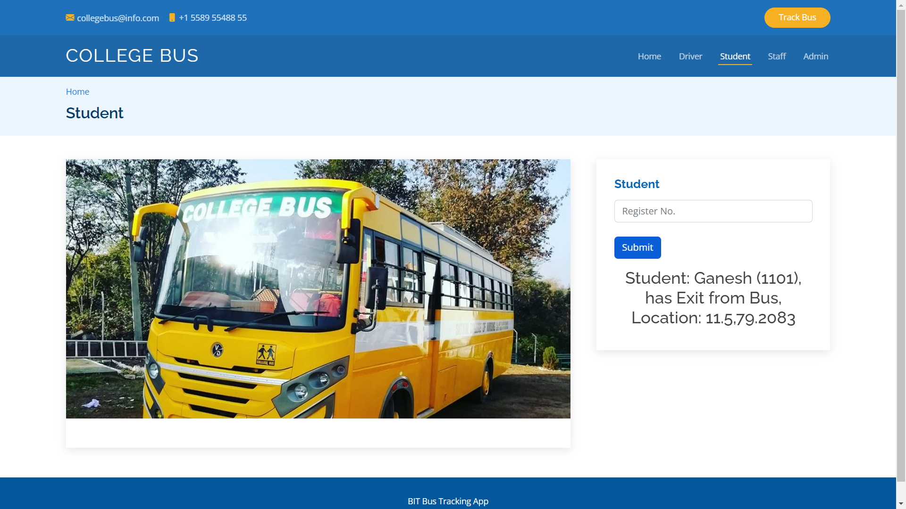

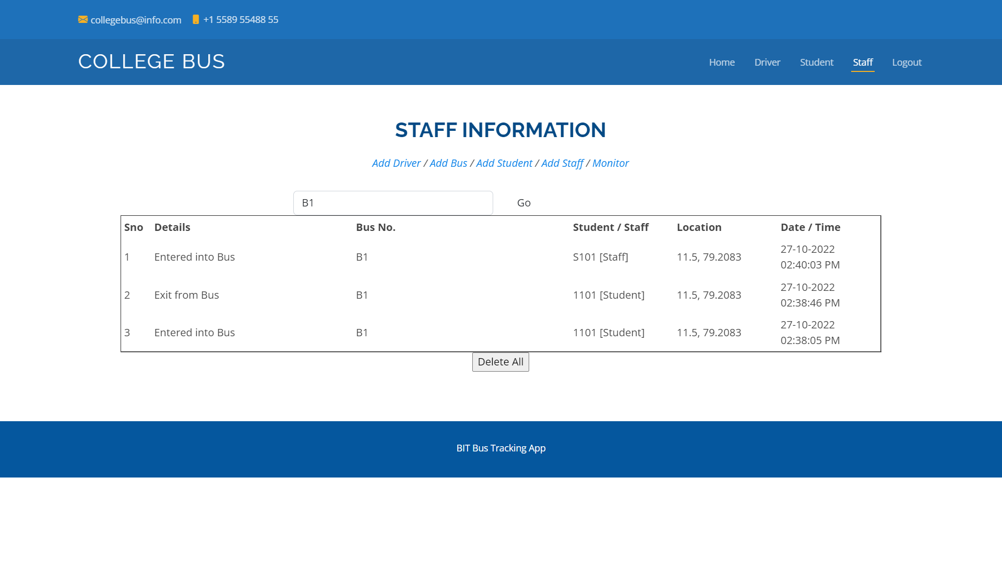

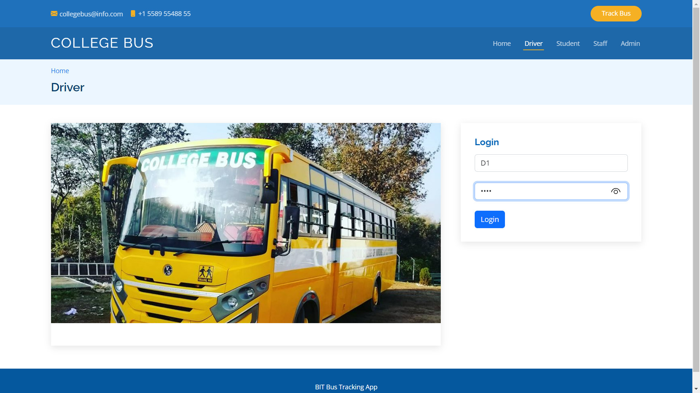

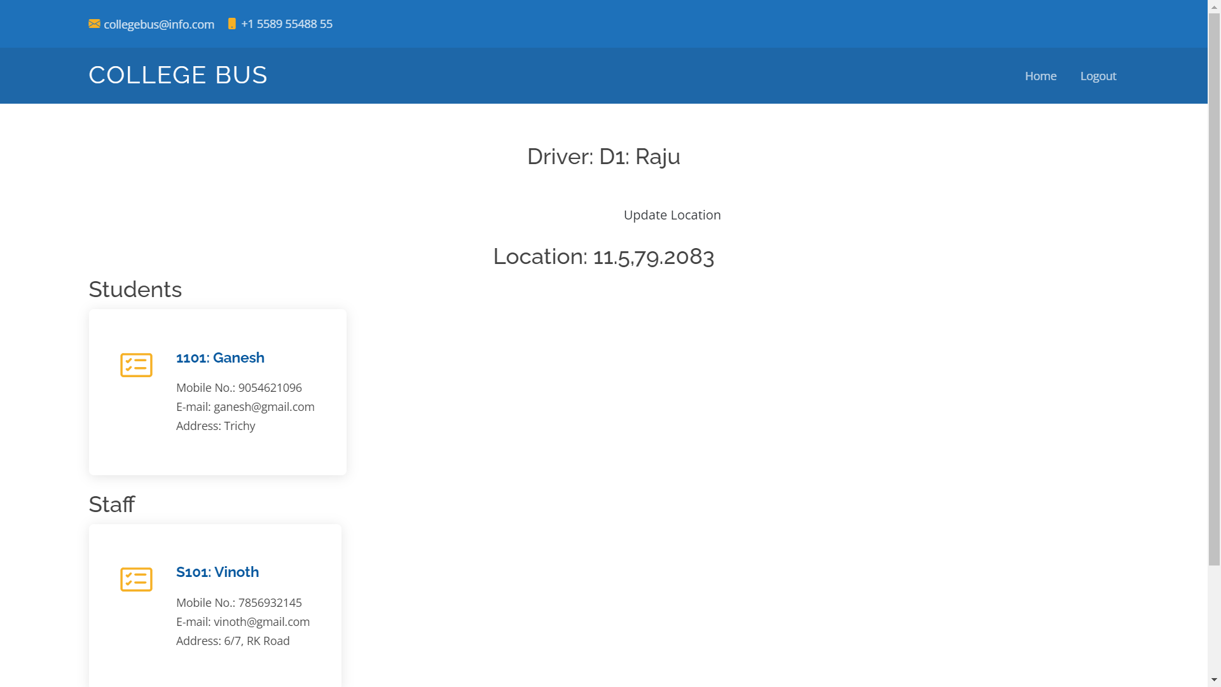

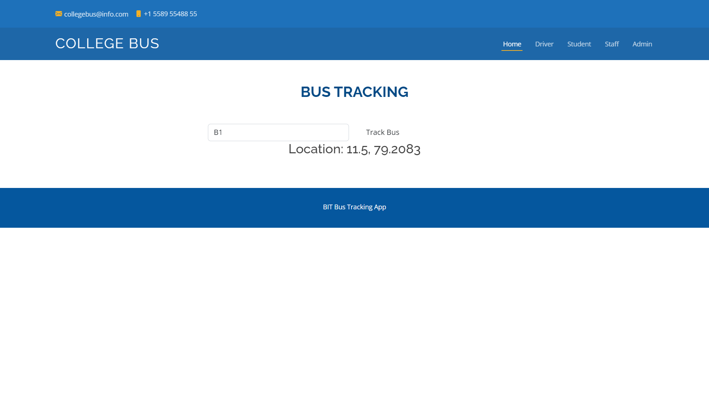

**Add Bus**

<?php

include("protect_admin.php");

include("dbconnect.php");

extract($_REQUEST);

if(isset($btn))

{

$mq=mysqli_query($connect,"select max(id) from sbus_bus");

$mr=mysqli_fetch_array($mq);

$id=$mr['max(id)']+1;

$ins=mysqli_query($connect,"insert into sbus_bus(id,busno,driver) values($id,'$busno','$driver')");

if($ins)

{

mysqli_query($connect,"update sbus_driver set busno='$busno' where uname='$driver'");

$mq2=mysqli_query($connect,"select max(id) from sbus_route");

$mr2=mysqli_fetch_array($mq2);

$id2=$mr2['max(id)']+1;

mysqli_query($connect,"insert into sbus_route(id,busno,route,lat,lon) values($id2,'$busno','BIT','$lat','$lon')");

?>

<script language="javascript">

alert("Added Successfully");

window.location.href="home.php";

</script>

<?php

}

else

{

$msg="Bus No. Already Exist!";

}

}

?>

**View Bus Information**

<div class="row">

<?php

$q1=mysqli_query($connect,"select * from sbus_bus");

$n1=mysqli_num_rows($q1);

if($n1>0)

{

while($r1=mysqli_fetch_array($q1))

{

$bn=$r1['busno'];

$q2=mysqli_query($connect,"select * from sbus_driver where busno='$bn'");

$r2=mysqli_fetch_array($q2);

?>

<div class="col-md-6 d-flex align-items-stretch" data-aos="fade-up" data-aos-delay="100">

<div class="icon-box">

<i class="bi bi-card-checklist"></i>

<h4><a href=""><?php echo "Bus No.:".$r1['busno']; ?></a></h4>

<p>Driver: <?php echo $r2['uname']."-".$r2['name']; ?></p>

<p>

<strong>Routes:</strong><br>

<?php

$q4=mysqli_query($connect,"select * from sbus_route where busno='$bn'");

?>

<table class="table">

<?php

while($r4=mysqli_fetch_array($q4))

{

?>

<tr>

<td><?php echo $r4['route']." - ".$r4['lat'].", ".$r4['lon']; ?></td>

<td><?php echo '<a href="home.php?act=rdel&rdid='.$r4['id'].'">Delete</a>'; ?></td>

</tr>

<?php

}

?>

</table>

</p>

<p align="right"><a href="add_route.php?busno=<?php echo $r1['busno']; ?>">Add Route</a> / <a href="home.php?act=del&did=<?php echo $r1['id']; ?>">Delete</a></p>

</div>

</div>

<?php

}

}

?>

**Driver**

<?php

session_start();

include("dbconnect.php");

extract($_REQUEST);

if(isset($btn))

{

$q1=mysqli_query($connect,"select * from sbus_driver where uname='$uname' && pass='$pass' ");

$n1=mysqli_num_rows($q1);

if($n1==1)

{

$_SESSION['driver']=$uname;

header("location:home_driver.php");

}

else

{

$msg="Username or Password wrong!";

}

}

?>

**Update GPS Location**

<?php

$uname=$_SESSION['driver'];

$q3=mysqli_query($connect,"select * from sbus_driver where uname='$uname'");

$r3=mysqli_fetch_array($q3);

$busno=$r3['busno'];

if(isset($btn))

{

$loc=$lat.",".$lon;

$message="Location: $loc";

mysqli_query($connect,"update sbus_bus set lat='$lat',lon='$lon' where busno='$busno'");

}

?>

<script>

var x = document.getElementById("demo");

function getLocation() {

if (navigator.geolocation) {

navigator.geolocation.getCurrentPosition(showPosition);

} else {

x.innerHTML = "Geolocation is not supported by this browser.";

}

}

function showPosition(position) {

//x.innerHTML = "Latitude: " + position.coords.latitude +

//"<br>Longitude: " + position.coords.longitude;

document.form1.lat.value=position.coords.latitude;

document.form1.lon.value=position.coords.longitude;

}

</script>

**Student Entry and Exit**

<?php

session_start();

include("dbconnect.php");

extract($_REQUEST);

$rdate=date("d-m-Y");

$ch1=mktime(date('h')+5,date('i')+30,date('s'));

$rtime=date('h:i:s A',$ch1);

$bus="bus_close.jpg";

if(isset($btn))

{

$loc=$lat.",".$lon;

$q1=mysqli_query($connect,"select * from sbus_reg where regno='$regno'");

$n1=mysqli_num_rows($q1);

if($n1>0)

{

$r1=mysqli_fetch_array($q1);

$busno=$r1['busno'];

$regno=$r1['regno'];

$name=$r1['name'];

$email=$r1['email'];

$q2=mysqli_query($connect,"select * from sbus_det where busno='$busno' && regno='$regno' order by id desc");

$n2=mysqli_num_rows($q2);

if($n2>0)

{

$r2=mysqli_fetch_array($q2);

$s1=$r2['stud_st'];

if($s1=="0")

{

$st='1';

$mess="Exit from Bus";

}

else

{

$st='0';

$mess="Entered into Bus";

}

}

else

{

$st='0';

$mess="Entered into Bus";

}

$mq=mysqli_query($connect,"select max(id) from sbus_det");

$mr=mysqli_fetch_array($mq);

$id=$mr['max(id)']+1;

mysqli_query($connect,"insert into sbus_det(id,details,lat,lon,busno,regno,stud_st,rdate,rtime,utype) values($id,'$mess','$lat','$lon','$busno','$regno','$st','$rdate','$rtime','Student')");

$message="Student: $name ($regno), has $mess, Location: $loc";

//echo '<iframe src="http://iotcloud.co.in/testmail/sendmail.php?message='.$message.'&email='.$email.'" style="display:none"></iframe>';

$bus="bus_open.jpg";

}

else

{

$bus="bus_close.jpg";

$st='2';

$mess="Unknown";

$mq=mysqli_query($connect,"select max(id) from sbus_det");

$mr=mysqli_fetch_array($mq);

$id=$mr['max(id)']+1;

mysqli_query($connect,"insert into sbus_det(id,details,lat,lon,busno,regno,stud_st,rdate,rtime) values($id,'$mess','$lat','$lon','$busno','','$st','$rdate','$rtime')");

$message="Unknown Person";

}

}

?>